Join the Board from the Waccamaw Youth Center “for a beautiful Christmas getaway — lights, music, laughter, and all the warmth of the season.”
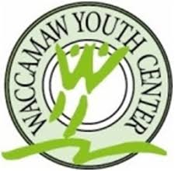
Southern Christmas Tour
“But this trip isn’t just about twinkling lights and holiday cheer.” “Every seat on that bus helps provide:
• Academic support
• Vocational training
• Counseling
• Life-skills development
• Safe, nurturing relationships”
“This season, your celebration can become someone else’s turning point.”
Saturday December 5, 2026

7:00 am Depart for tour from Coastal Grand Mall

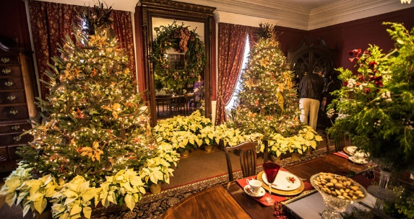
Meet your guide/escort who will provide you with homemade breakfast goodies – bring your own coffee, water will be provided. She will share some stories about when rice was King and the Christmas traditions of the time. Including stories sharing traditions of Christmas that began in the south.

9:00 am Christmas at Boone Hall
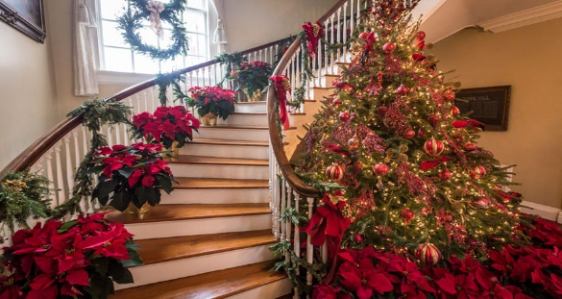
“A Traditional Christmas” the classic way it has been celebrated for many generations at Boone Hall Plantation. The sun glistens through Spanish Moss which drapes a ¾ mile corridor of 276 year old giant oak trees…a visual wonder that truly takes your breath away and confirms that God is alive and well at work. The Avenue of Oaks is one of nature’s greatest spectacles…and THIS is Boone Hall Plantation.
The plantation mansion and grounds are decorated with beautiful Christmas decorations of every kind.. Yes…there’s plenty of beautiful Christmas trees in every room yet if you look closely, you will see some things that are very unique about the decorations. There are decorations made with cotton and berries grown right on the plantation. There are wreaths made from magnolia tree leaves also grown on these historical grounds. . It’s traditional Christmas holiday decorating at its finest.
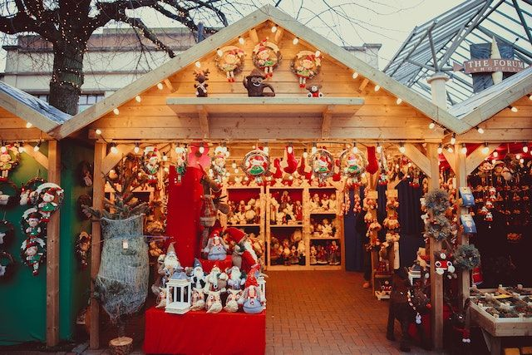
You will have a tour of the house, gardens, time in cabins, Gullah Theatre and Wagon ride. Café on site for snack of lunch.
12:00 pm Charleston’s Farmer’s and Holiday Market

You'll find everything you need to deck the halls for the holidays and fill the pantry with local goodies, all from local farmers, growers, artisans and crafters. Browse a wide assortment of art, crafts and holiday gift items and get your holiday shopping done early. What was the original purpose of Christmas markets?
These stalls originated in German-speaking Europe when farmers saw an opportunity to extend their weekly markets during the Christmas period, dell selling meat for winter feasts. One such market was recorded as early as 1296 in Vienna, Austria.

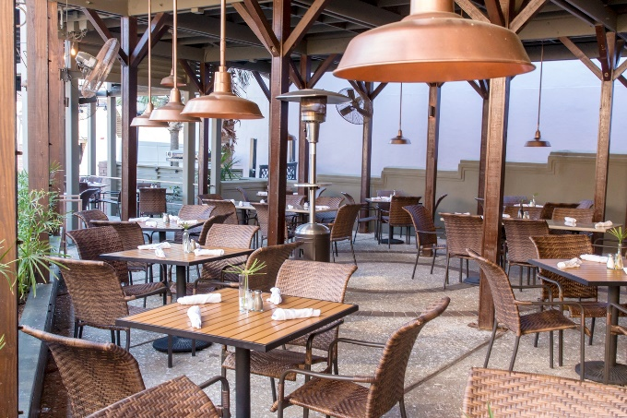
4:00 pm Depart for Market Street
4:30 pm Dinner at the Oyster House Sample menu
Dinner Menu
First Course
House Salad Mixed greensranch dressing
Second Course
- Fried Shrimp Dinner Golden fried shrimp, coleslaw, fries
- Chef's Fresh Catch* Chef's fresh catch, Charleston red rice, crispy Brussels sprouts
- Shrimp and Grits Sautéed shrimp and tasso gravy, served over white stone ground grits
- Crab Cake Pan-seared lump crab cake, remoulade, white stone ground grits, grilled asparagus Grilled Chicken Veggie Pasta Grilled chicken, seasonal vegetables, garlic scampi butter
Third Course
Key Lime Pie
Includes: hushpuppies, tea, soda, and coffee

5:30 pm Night Market

Time in the Market with extended hours We are the largest art market in the southeast and have won Charleston choice for Local Art in 2018 and 2019, 2021, 2022. The Night Market began as an Artisan/Handcrafted only market in 2013 and now over 200 various artists represented. This dynamic and diverse group has become an integral part od the Charleston City Market. This is located between Church Street and East Bay Street, each Friday and Saturday nights 6:30 TO 10:30, from March through December. .

7:00 pm Depart
9:00 pm Return

To register – Fill out the form below

Package includes: Transportation – Carolina Motorcoach, Boone Hall, Holiday Market on Marion Square, Time at Night Public Market, Dinner at the Crab House – choice of meal at seating, and the Night Market, professional guide/escort all tips.

Cost of the package is $250.00 per person. Don’t miss out have a time and helping those young men. All proceeds go to the Center. The bus will fill quickly.

Name _______________________________________________________________

Address_______________________________________________________________

Email___________________________________Cell # _____________________________

Additional donation if applicable _______________________________________

# of seats $250.00 X ______ # People = _______+ ______ donation – total sent _________

Make the checks payable to Waccamaw Youth Center. Send it to 301 Padgett Ln, Conway, SC 29526.

All-In On Tours have made the arrangements. If you have any questions call Cathy at 717 201-4381.

